Jasmine Brown

Data Science

Introduction

3 July 2019

The Digital Video Game Take Over

**Introduction**

Video games have been around for almost 70 years capturing the mind of people. There have been many popular remakes and changes made to the counsels and disk. The super Nintendo had the bulky games to insert in the top of the counsel how games are being downloaded from a play store. There is revenue from disk compatible with the Xbox, PlayStation, and Nintendo switch. However, selling these products may be challenging because of the change in video gaming and systems. It is more convenient to have a digital video game. Which is to download a game from an application store rather than going to the store on the night of a release and waiting in line. There could be a decrease in hardware sales because of the push to complete online. There is multiple fighting, racing, and other games all created to be released around the same time frame. There are also many new innovations in technology that gives a consumer access to games on other devices such as tablets, phones, and gaming computer. The data analysis of the video game sales with the genre, type, and conceal results could have an impact of the game next year. There are many questions to be answered with the data that is present. Have there been a decrease in buying of video games? Are cellphones and the digital games taking over the video game industry? Since virtual video games have infiltrated the industry, the hypothesis that hardware sales have declined.

The First steps were to insert the packages by declaring the libraries. The ply package is to be used to select the variables in the clean data and the tidy verse for most of the other functions.

**Exploratory Data Analysis**

To begin the cleaning, we have to set the working directory, import the data, and then look at the data.

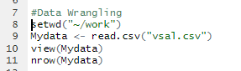

The view function gave us a table to view all 55,792 observation and twenty- three variables. Some of the variables were easier to understand that others. The ones such as Game, Rank, Name, Total shipped were plain. The variables such as Data score, Rating, and Sales did not have units specified. The dplry package came in handy when time to select the variables needed for the research’s Na. Omit function was also used to remove the variable with missing data points.

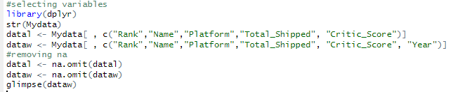

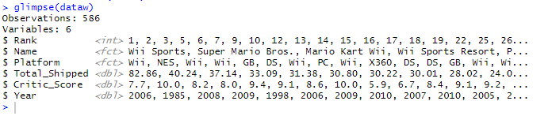

The new dataset has 586 observations and 6 variables’ data is cleaned and save as a new set name Dataw. We can begin the data exploration by using the sapply and class on the dataset to view the types of data that are in each variable. There is a mix of numerical and factorial.



This now gives of a chance to the types of plots that can be created with the data. I first look at the differences in means for the total shipped and critic score.

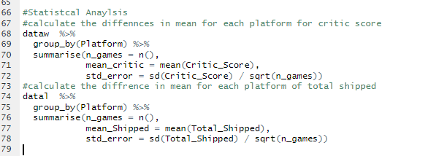

This data shows the number of games for each platform each. Dataw also shows that the Nintendo Entertainment System (NES) had the highest mean shipped and the high mean for critic score but the least games shipped.

In 2011 had the highest number of games shipped. After 2011 after that that year the number of games started to decline ass as whole. We made the Assumptions that after the years of the internet they may be started to be order online rather than being shipped. Looking at the variables total shipped versus platform.

On this graph we see that the Wii has a higher total shipped than any other platform. The data set id from the years of 1985 to 2019. That may have a large effect on the platforms with number f games shipped. We could make that assumptions that at that year the stores were popular with that game.